Where was this video when we were doing all those fancy calcs??

<https://www.youtube.com/watch?v=vpN-myfTAOs>

This will either be in the weedy weed-free plots or the subsoiled plots either way the numbers are the same.

For this year let’s focus on the 300 and 400 plots

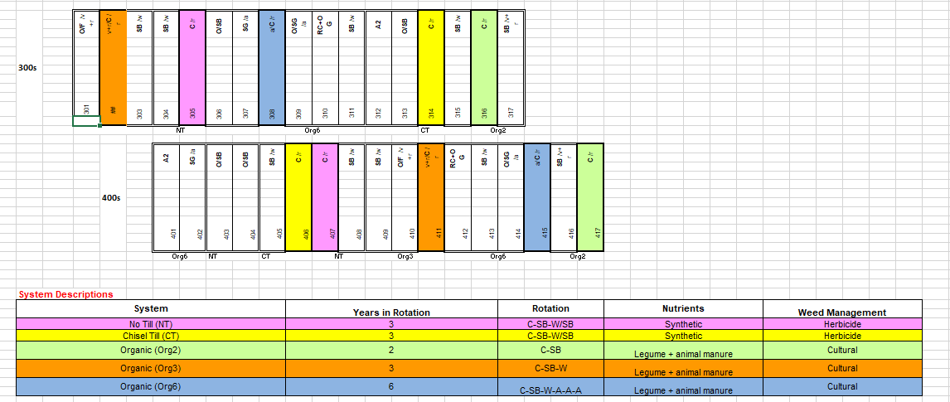

There are 5 trts (org/CT/NT)

1 weedy in each plot

1 weed free in each plot

5 * 2 = 10

2 reps

10 *2 = 20

2 positions per plot

2*20 = **40**

*Basically:*

*5 ttms * 2 reps for each ttmt = 10 plots*

*10 plots * 2 microplots (W/WF) = 20 microplots*

*20 microplots * 2 positions per microplot (either side, facing in) =* ***40*** *structures*

Or

*2 positions per microplot (either side, facing in) * 10 plots * 2 microplots/plot =* ***40*** *structures*

Add a few spares (4 to 5) - So shoot for 45 units.

Halving:

*2 positions per microplot * 5 plots * 2 microplots/plot =* ***20*** *structures*

* *13 for NC = 33 total needed*

1. We will start when the corn is about 1 foot tall maybe 2 ft tall

2. Collect data until corn is ~12ft tall - should be close to maturity at that point

3. Place structure within row (not between rows) so that tractor can till between rows without hitting it. PVC piece may stick out of soil about 6 inches and tractor may pass over top of it. Before tilling/spraying, we will remove upper part of PVC structures from field. We will cover remaining 6 inches with a cap or bag with fluorescent tape or paint.

Cap ideas:

1 ¾” PVC cap - can’t find. Not at home depot. Also checked here, didn’t see anything :

<https://www.pvcfittingsonline.com/catalogsearch/result/index/?cat=0&p=2&q=1+3%2F4%22+PVC+caps>

Foam: <https://www.homedepot.com/p/Future-Foam-2-in-Thick-Multi-Purpose-Foam-10030BULK2/203837080>

Bags: Have about 10 (need about 45) (from adafruit/mouser pieces)

T-pvc piece (still gets dirt in it)

Fluorescent tape or spray paint

Sock - spray painted (Expensive $$)

Random site - orange plug things <https://www.usplastic.com/catalog/item.aspx?sku=42106&gclid=CjwKCAjwm-fkBRBBEiwA966fZGMVkxWzbMw8dPwTuDOWuHGcTtd4bR0YtrdnYo4nZEb-FhkhHNBqjBoCilIQAvD_BwE>

**Auger:** Need 1 - ¾” hole

**Oakfield:**

Does not appear to allow you to change auger size

<https://www.soilsamplers.com/collections/soil-augers>

**AMS:**

1 ¾” flight auger

<https://www.ams-samplers.com/1-3-4-x-12-flighted-screw-auger-not-for-use-with-electric-hammer-drills.html>

1 ¾” flight auger - quick connect: ($20 more)

<https://www.ams-samplers.com/1-3-4-x-12-qc-flighted-screw-auger-not-for-use-with-electric-hammer-drills.html>

**Solar**:

This is our panel: <https://webosolar.com/store/en/12v-24v-solar-panels/973-solarland-3watt-12volt-polycrystalline-solar-module-slp003-12u.html>

And datasheet: file:///C:/Users/Rebecca.Hartman/Downloads/SLP003-12_3W_12V.pdf

Goal: Want to regulate power - at night, don’t want power to leave battery through solar panel (diode will prevent this), and during day, don’t want to overcharge battery. Solution? Solar charge controller

Why not use this before? Voltage regulator/diode combo not enough?

Pricey: ($44)

<https://webosolar.com/store/en/pwm-controllers/1611-phocos-cmlup-20-amps-charge-controller-12-24-volts.html>

Pricey: ($50) (<https://webosolar.com/store/en/pwm-controllers/1670-phocos-eco-n-10-t-encapsulated-charge-controller-10a-12-24v.html>

Good price!: ($12.29)

<https://www.amazon.com/dp/B0742CJFTZ?tag=lds074-20>

Make it ourselves: (video ideas) <https://www.youtube.com/results?search_query=how+to+make+solar+charge+controller+pcb>

Integrated circuit (all components on a little chip) for charge controller (keeps voltage from leaving battery at night or over-charging it during day) for 12V SLA battery (SLA vs Lithium)

* Steve: Help?

IC: (BQ24650) Great price!! ($3.85) description: <http://www.ti.com/product/BQ24650/description> and datasheet: <http://www.ti.com/lit/ug/sluu444a/sluu444a.pdf>

Examples of implementation: <http://www.ti.com/lit/an/slyt466/slyt466.pdf> and <http://www.ti.com/lit/an/slyt424/slyt424.pdf>

Charge controller Alondra has used in previous projects (Phocos) manual: <https://www.phocos.com/wp-content/uploads/2016/05/181802512-CA-final-manual.pdf>

10 Amp charge controller we ordered: <https://www.amazon.com/dp/B007VLMRP2?tag=lds074-20&th=1>

Product description of what we ordered:

<https://www.anself.com/p-h17919-1.html>

The idea:

* “Auto-detects 24V and 12V battery arrays, measures their charge state and decides to charge them when there is excess power. It also supplies the load with the solar cell when there is excess power and it won't let the batteries discharge below a recommended state while powering the load! That means it powers the load from the batteries at night and will turn the load off once the batteries reach their discharge point. So this is much more than just a charge controller! It's a smart load controller too!”

Problems with our charge controllers:

* No load across some load terminals
* When power supply drops below ___V, charge controller stops and no power is supplied

Troubleshooting from Amazon reviews:

* “I received a faulty one so the seller sent me a replacement and now after almost a year the replacement stopped working. No voltage on the load output. The seller quickly send a replacement but took a while to arrive because it came from China. It is working perfect, I guess I just got a faulty one the first time”
* “Every 7-10 days the battery would go dead and I'd have to take it in the barn and charge it. I got out the amp meter and starting doing some measuring. This charge controller was drawing .1A all the time!”
* “I removed the front panel and saw that there is a 15 amp mini blade fuse on the circuit board. When I touched the wires together this blew the fuse. I have ordered some 15 amp mini fuses as replacements which should restore the power out. My guess is that this fuse blowing has been the problem many folks have had with their unit. It would have been nice if the MFG. had mentioned this fuse and included at least one spare. Luckily it is easy to remove the cover and replace the fuse. Hope this helps folks out there who have this product.

PS:

* The unit comes with two open holes on the side for screwing it onto a piece of wood.

Resource on how to set up basic solar panel setup: <https://www.instructables.com/id/Solar-Battery-Charging/>

Connectors: - Went with red because easiest to connect wires to and pull off board

Red - not great. Wires can come out, dangerous to make

Too many pins?: <https://www.mouser.com/ProductDetail/Molex/51047-0800?qs=sGAEpiMZZMs%252BGHln7q6pm7sC7%252B9pgVHnkvABjE13dOM%3D>

Mate?:

<https://www.mouser.com/ProductDetail/Molex/53261-7004?qs=sGAEpiMZZMs%252BGHln7q6pm8Vn94ktop%2FJoGVa76opMEFFbjHGN1nbYg%3D%3D>

Another possibility? <https://www.mouser.com/ProductDetail/Molex/47054-1000?qs=RQ9zk%252B50r5G5REkKmXuucQ%3D%3D&gclid=CjwKCAjwvuzkBRAhEiwA9E3FUsocP1qZfoQDRaOgzrsGd8yFP-k0Li9-Uwwdd4Yc8tCNUar9Ugjy2xoC2qQQAvD_BwE>

Would like to try: <https://core-electronics.com.au/4-pin-female-polarized-header-connector.html>

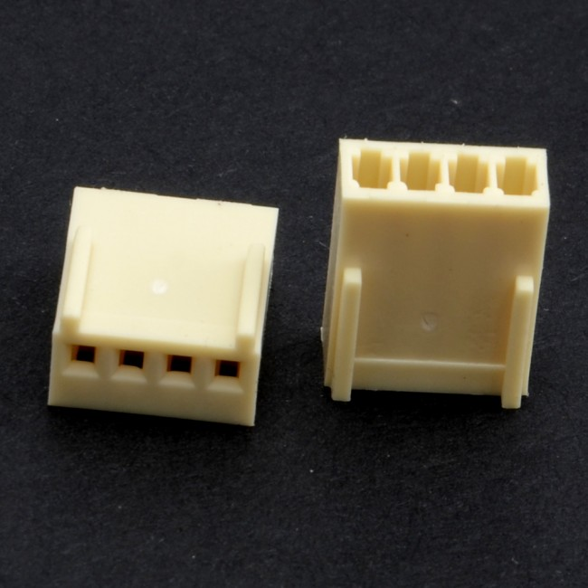And use screw driver/something thin but strong to separate connections. Need crimp pins of the correct size though. Website directed to here for pins?

<https://core-electronics.com.au/polarized-connectors-crimp-pins.html>

* If use screw driver to separate connectors and it touches multiple pins, will that mess things up?
* Are there different size crimp pins?

Could also do simple non-polarized black connectors, but invariably, someone will at some point put it on the connector the wrong way